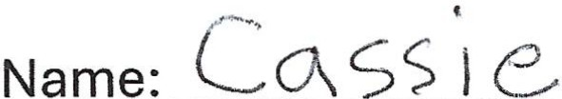
ME, MY FAMILY, AND FRIENDS

Dan and Paula Compton [Friends/ Systems Connect]
Linde and Mark � •
~Pickles-
Cassie Murphy

Jack and Connie [Daddy and Momma]

Mandy [Sister]

[Grandparents]

~Teddy and Taffy~

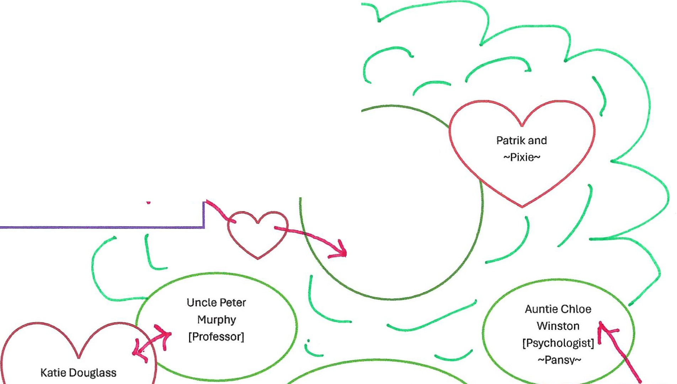
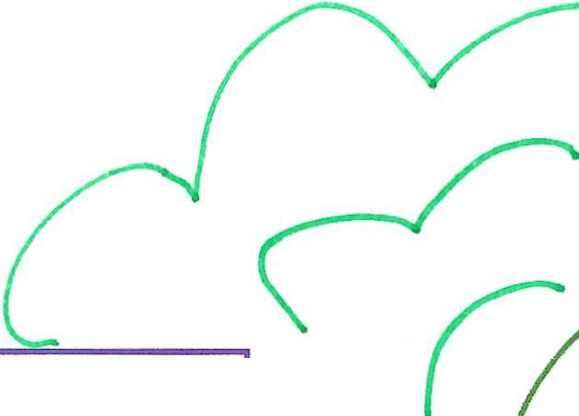
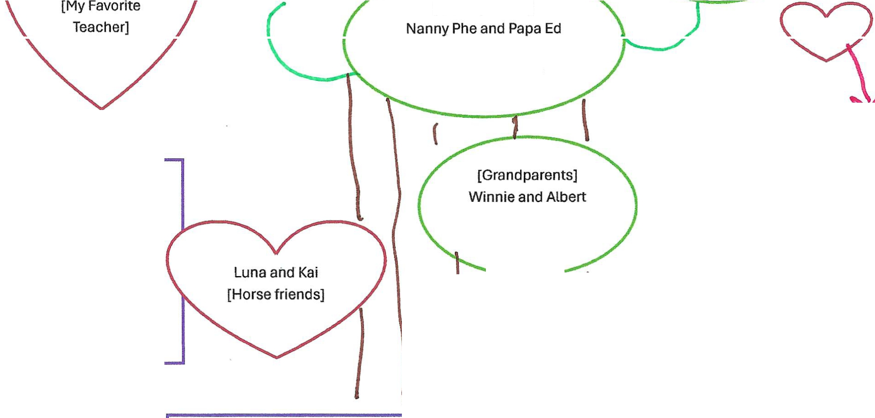
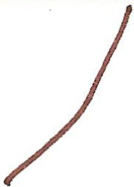
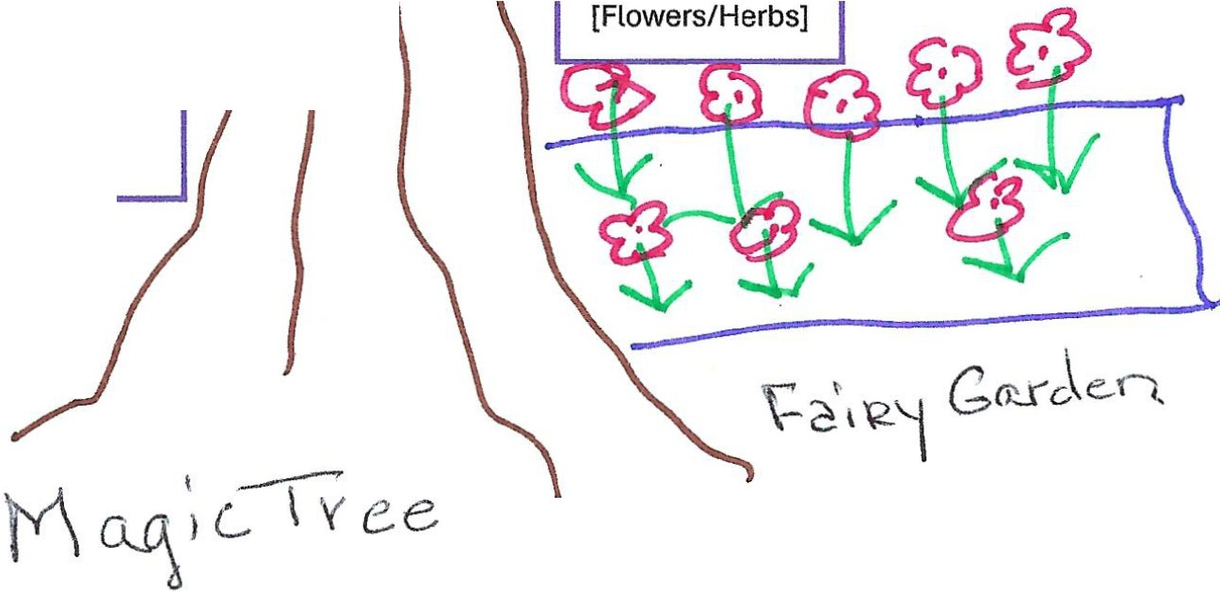

Winston
[Best friends next door] Mike and Millie Cavanaugh
[Darby's Store] [Veterinarian]

Kaitlyn and Kevin [Little twin friends]
Steven Donovan [Veterinarian]

Matt
[Best Magician Friend]
~Merlin~

Twirla Divine [Dance Instructor The Kick'n Leg]
Jim and Ivy Morgan [Neighbors]

Poppy
[Best friends across the street]

